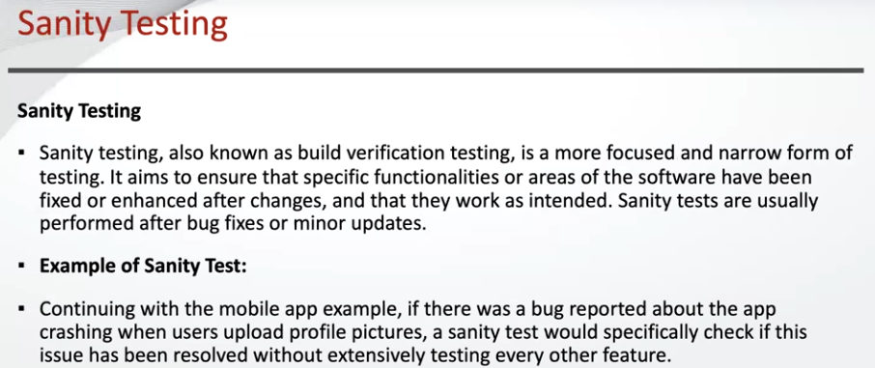

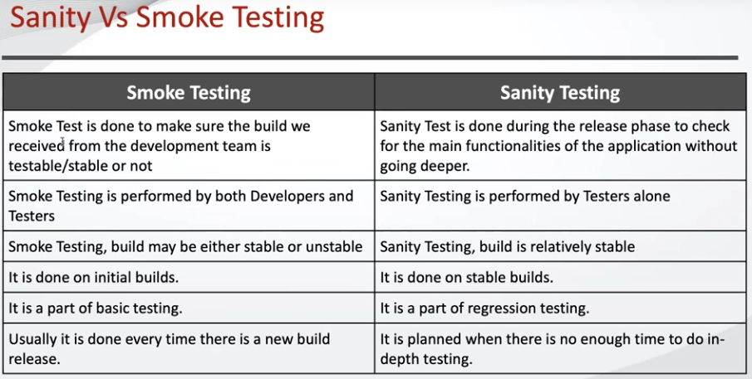

Smoke - build verification test, we test the stability of the build

Sanity testing - basic functionality testing (we do not care about build stability, we do care about basic functionality)